**CRUMB RUBBER**

**HERO**

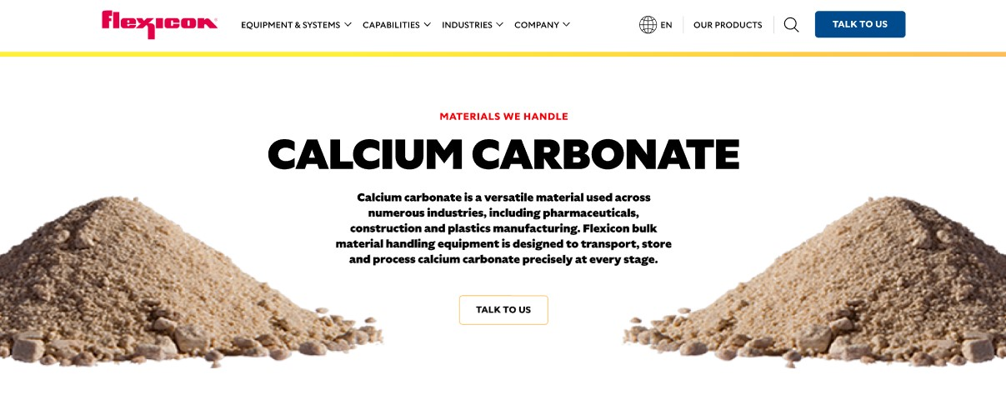

Crumb rubber is a recycled material with a wide range of industrial and commercial uses, from road construction to playground safety surfaces. Flexicon bulk material handling equipment is engineered to convey, store, and process crumb rubber efficiently throughout your process.

**Button**: Talk To Us

**SHELF #1 - PRODUCT DESCRIPTION**

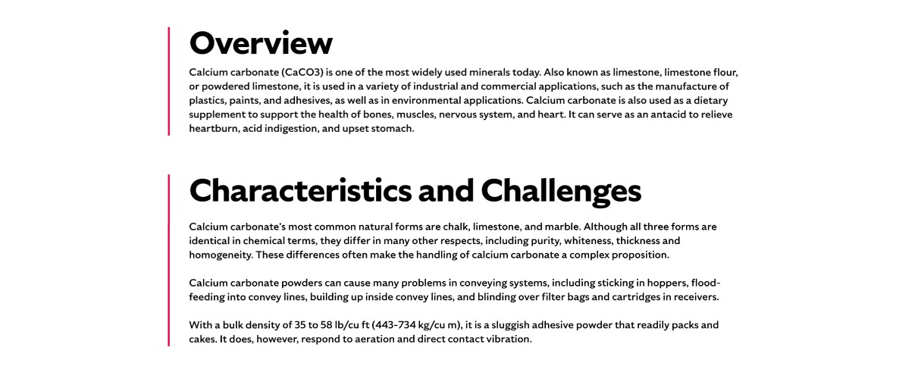

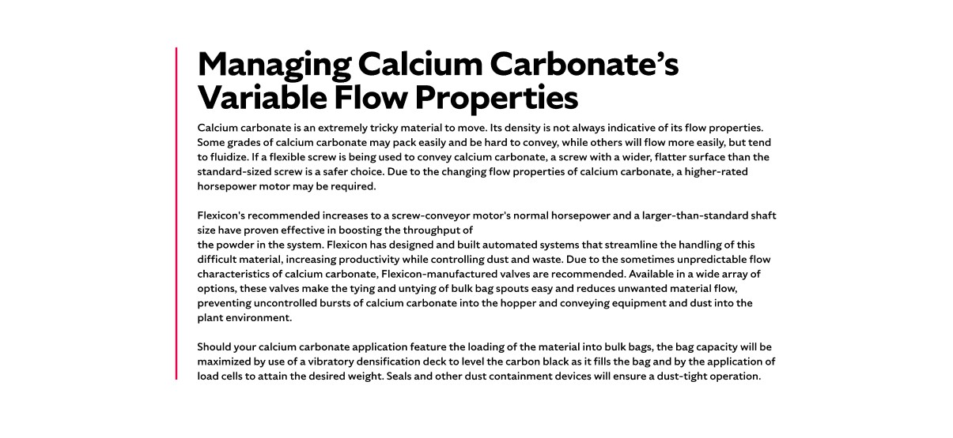

* **Overview**Also known as ground rubber, asphalt rubber, or size-reduced rubber, crumb rubber is produced by grinding recycled tires into smaller particles. The demand for crumb rubber continues to grow alongside the increasing emphasis on recycled materials and sustainability. Its largest application is in asphalt rubber for highway construction, consuming millions of tires annually to enhance road durability. Beyond roadways, crumb rubber is used in playground surfaces, running tracks, soil additives, molded rubber products, automotive parts, and agricultural applications.
* **Characteristics and Challenges**

Crumb rubber particles vary widely in size, shape, and color due to different processing methods and grades. Typically, it has a bulk density around 22 lb/cu ft but can include irregularly shaped particles that may vary within the same shipment. These variations require careful handling to maintain material flow and prevent agglomeration.

Crumb rubber has a natural tendency to clump together and cause blockages within conveying systems if not managed properly. This issue is particularly critical during pneumatic conveying, where the balance between air velocity and the specific grade of crumb rubber must be carefully controlled to prevent material segregation and plugging. Variations in particle size and shape can exacerbate flow problems, making it essential to use specialized equipment such as particle reduction devices or flow conditioners. These solutions help break down agglomerates, maintain consistent material flow, and ensure reliable, uninterrupted handling throughout the process.

**SHELF #2 - FLEXICON SOLUTIONS**

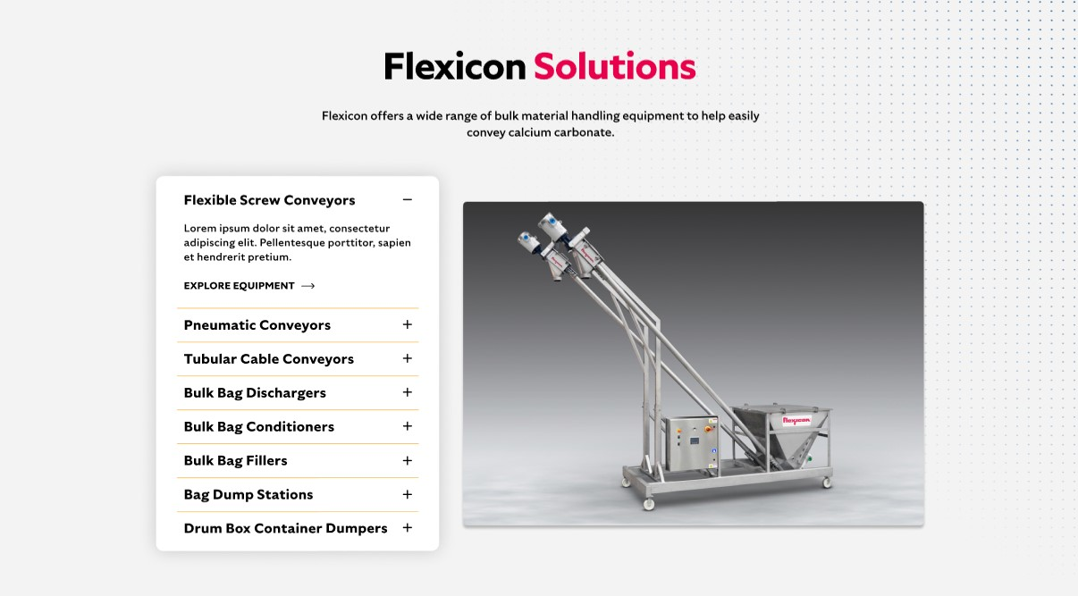

**Flexicon Solutions**

Flexicon offers a wide range of bulk material handling equipment to help easily convey calcium carbonate.

* **Flexible Screw Conveyor**: Efficiently transport crumb rubber with variable spiral geometries designed to optimize flow and prevent material build-up.
* **Pneumatic Conveyors**: Safely convey crumb rubber using controlled air velocity to minimize segregation and plugging.
* **Tubular Cable Conveyors**: Provide gentle, enclosed conveying that protects crumb rubber integrity while ensuring consistent flow.
* **Bulk Bag Dischargers**: Discharge crumb rubber from bulk bags completely using spring-loaded frames and bag activators to maximize material extraction.
* **Bulk Bag Conditioners**: Promote flow by agitating crumb rubber in bulk bags and preventing bridging or clumping during discharge.
* **Bulk Bag Fillers**: Fill bulk bags efficiently with vibratory densification and load cells to maximize capacity and control weight.
* **Bag Dump Stations**: Allow safe manual unloading of smaller bags with dust containment features for a clean work environment.
* **Drum Box Container Dumpers**: Handle various containers with ergonomic dumping systems designed to reduce dust and ease material transfer.

**SHELF #3: LIFETIME PERFORMANCE GUARANTEE**

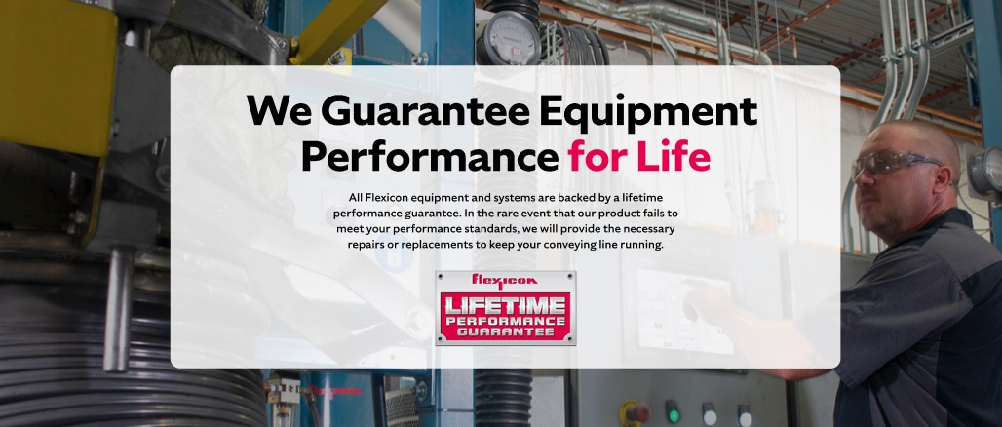

**Lifetime Performance Guarantee**

All Flexicon equipment and systems are backed by a lifetime performance guarantee. In the rare event that our product fails to meet your performance standards, we will provide the necessary repairs or replacements to keep your conveying line running.

**SHELF #4: CASE STUDIES**

